Linux Basics

echo $0 -- will help us to tell the current shell
/ (forward slash) root directory
pwd – present working directory
cd – change directory
/ is the root directory
/ below only will see the different files like bin, etc, temp…,
Each directory has a different purposes
~ (Tild) home directory
.. previous directory or previous file
cd .. it will goes to the previous folder
cd ../.. it will go to back back (twice back)
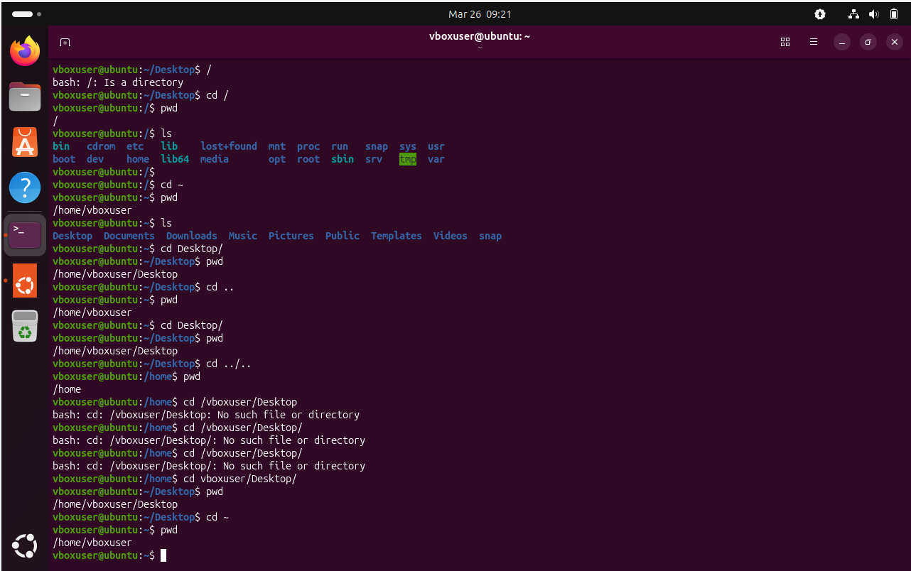
ls – list of files or directories in your location
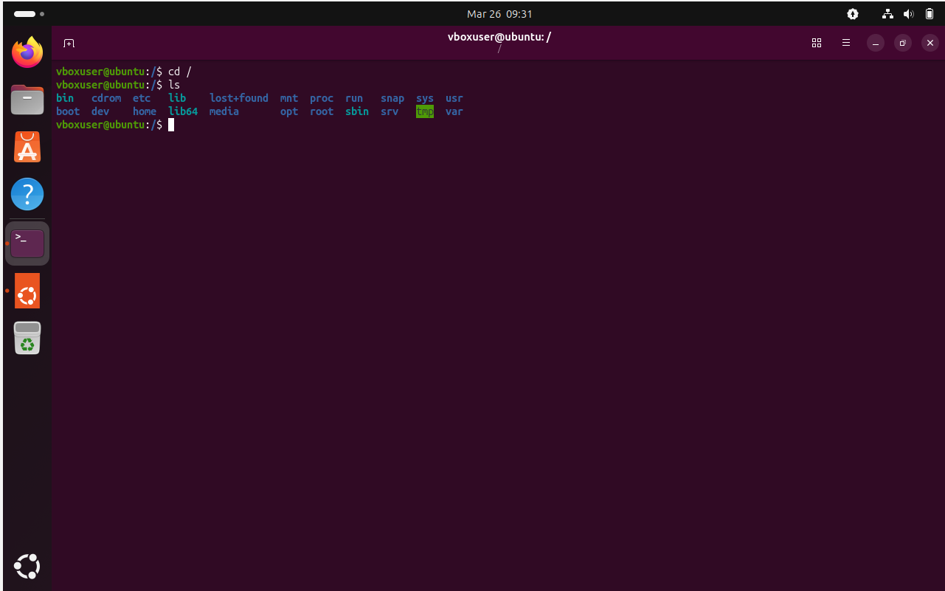
ll – long list of al l files and details as well
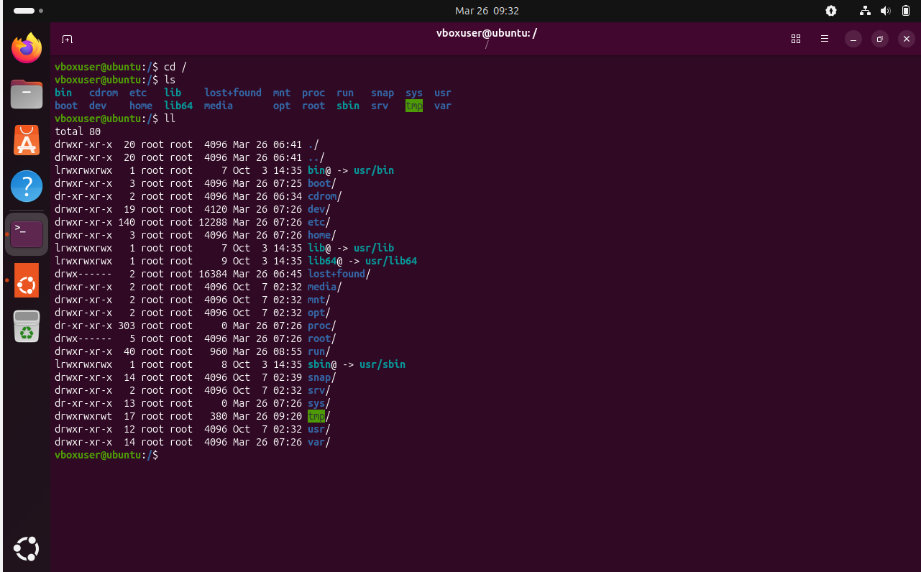
ls -ltr – it is also same like ll ,
-l it wil show all the files and details including file size, owner and permission and date of creation
-t -specific that the listing should be sorted by modification time
-r reverse sorting, means the new files & directories appears at the top
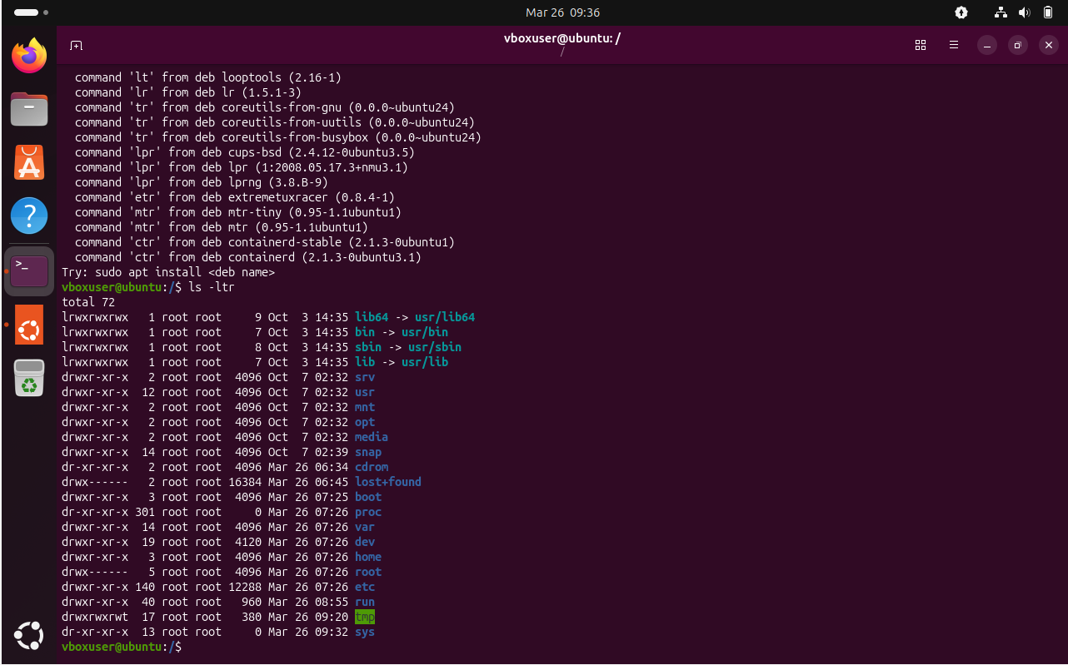
ls -a it will show the list of all files + hidden files
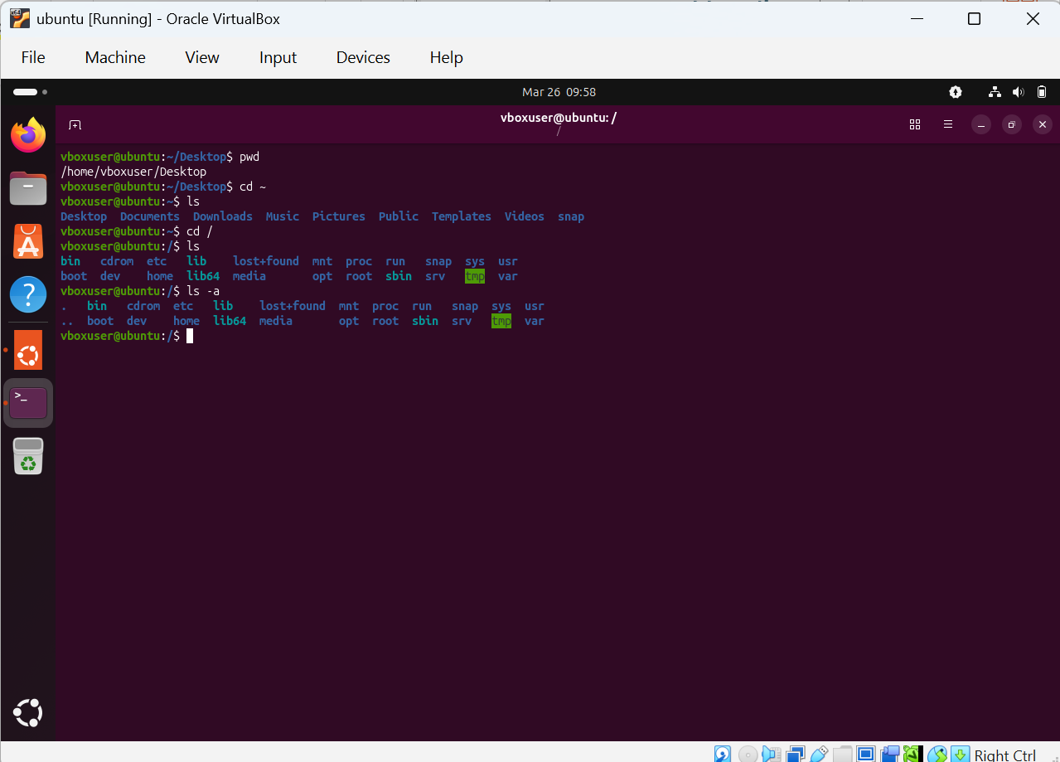
mkdir – it will help us to create a directory
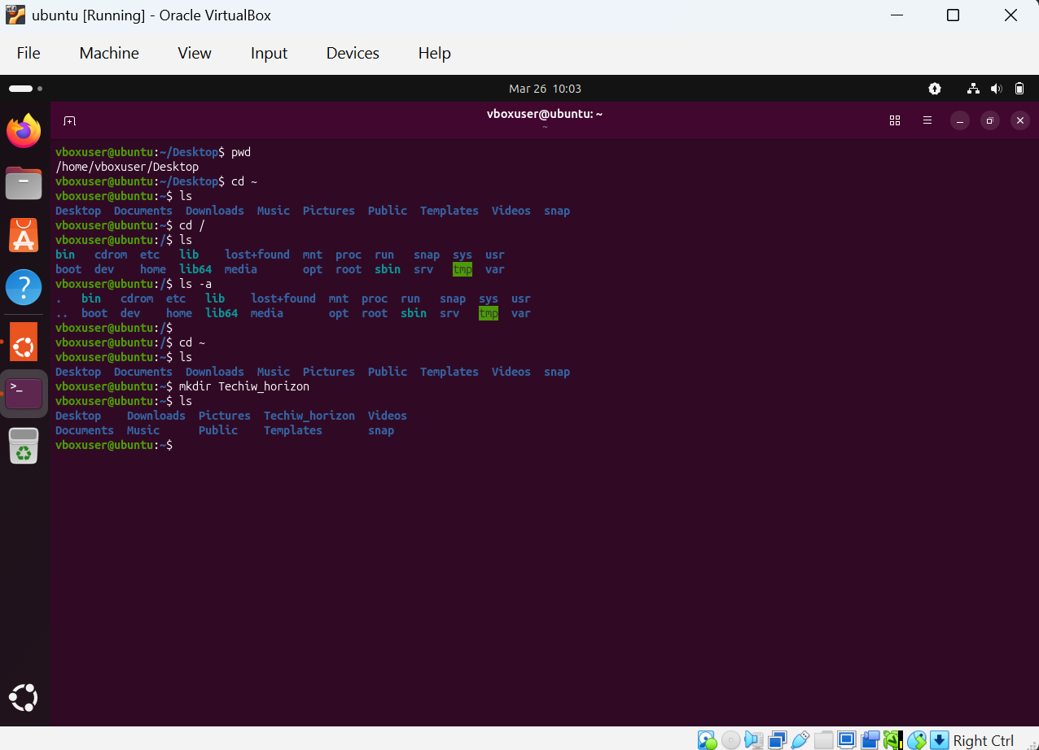
mv it is used for the rename and move the directory or file
.(dot) is used for hidden file
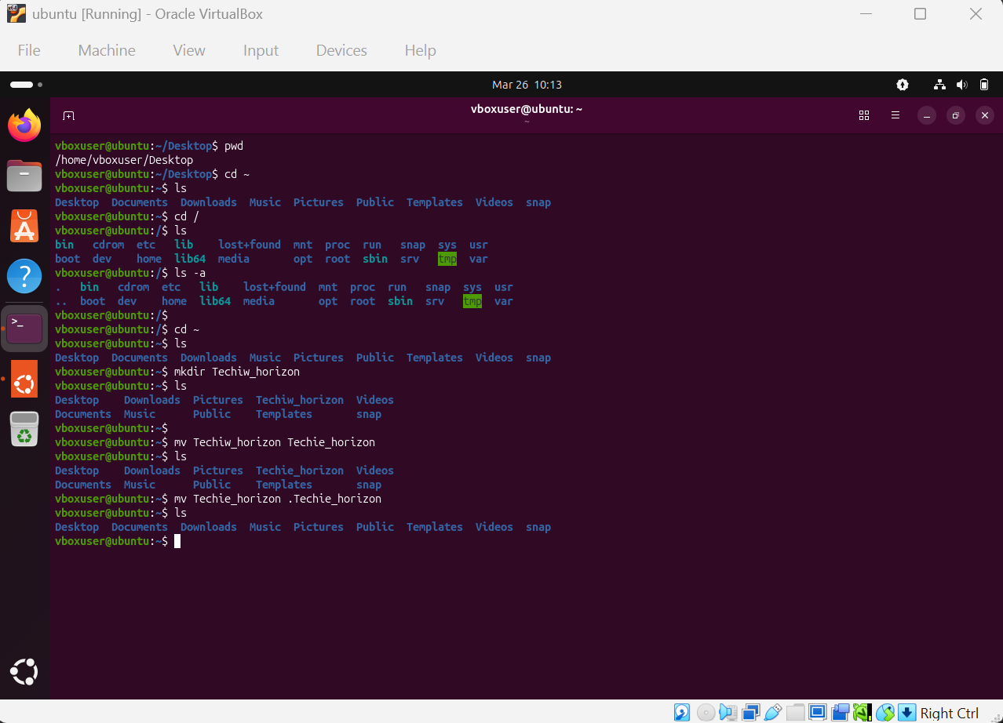
rm -rf used for removing the file or directory permanently
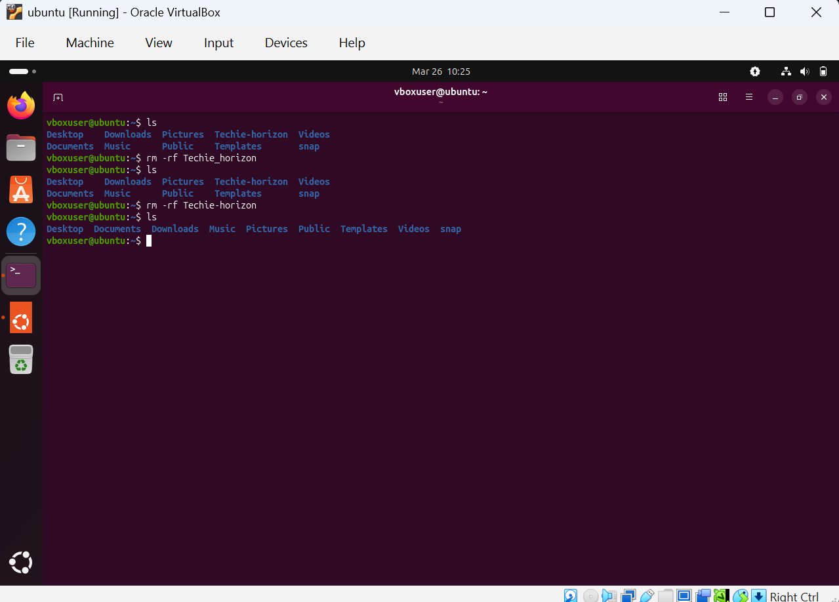

mv – move the folder or file from to the other folder
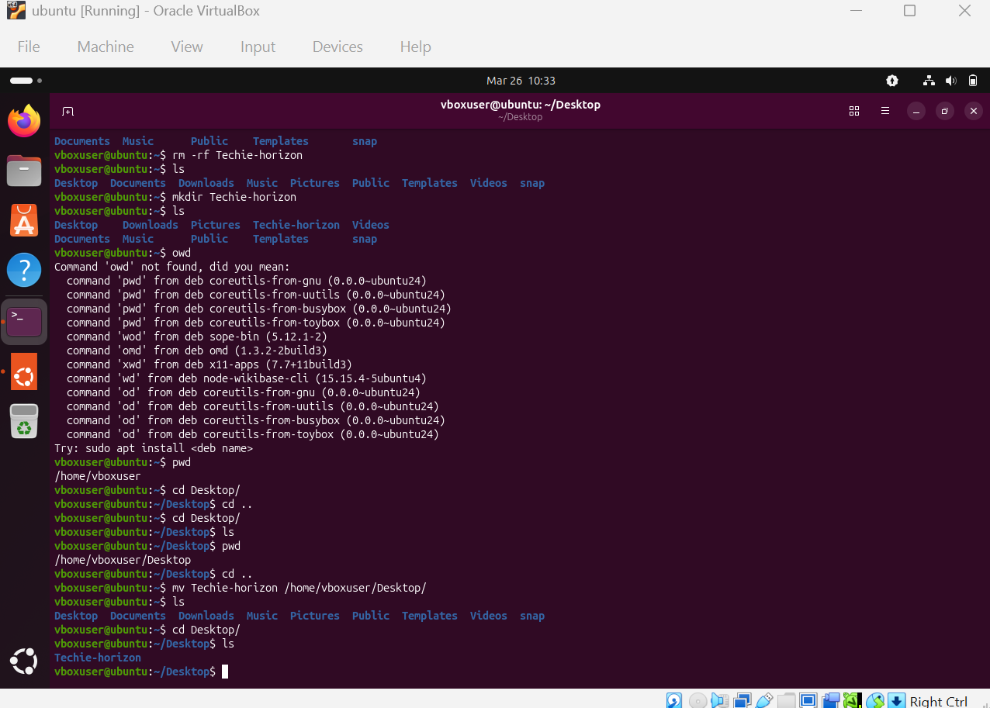
cp used for copy the file
cp -r means recursively copy all the files inside the folder
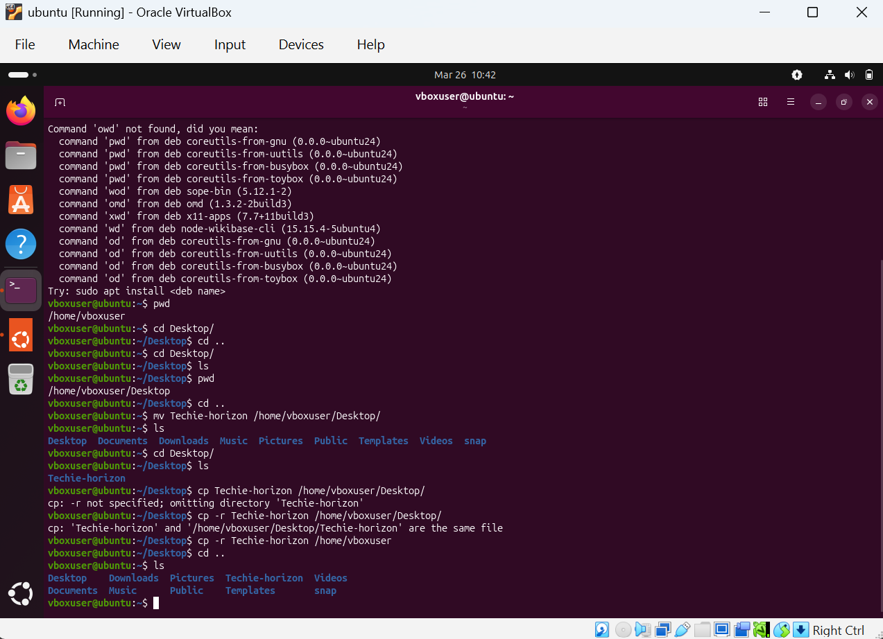
vi used to edit the file inside
we should make this editor into side mode by using keyword ‘i’ & write something like Hello World & then to exit use escape button and use :wq!
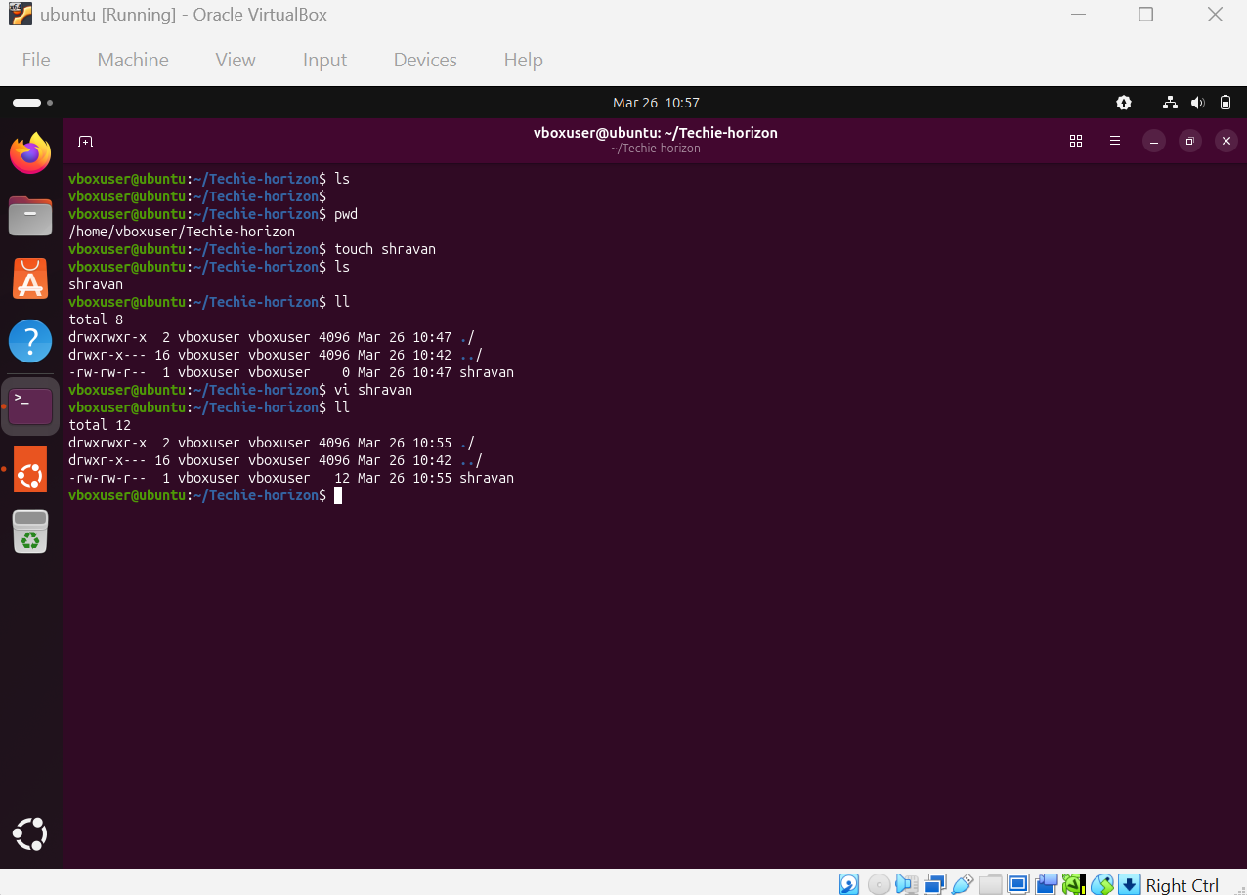
cat used to read the content
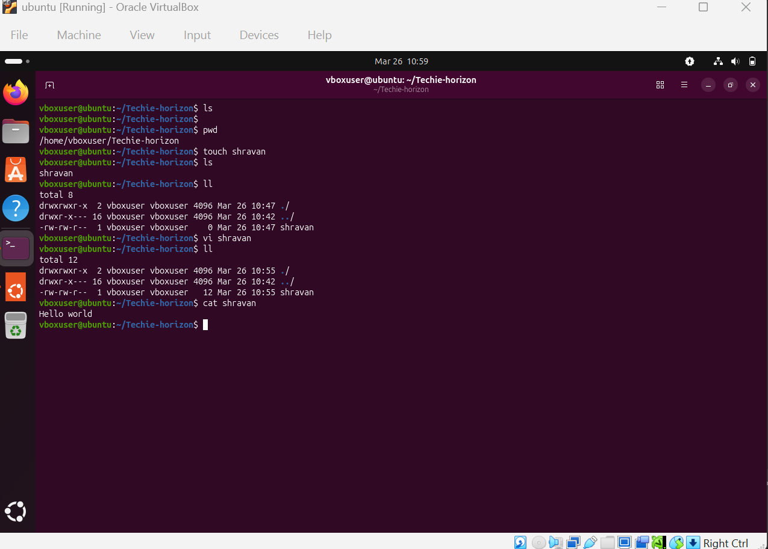
To create a file and write something we can use vi command
For example for vi world, so iin this we created a file name world and inside we wrote as hello
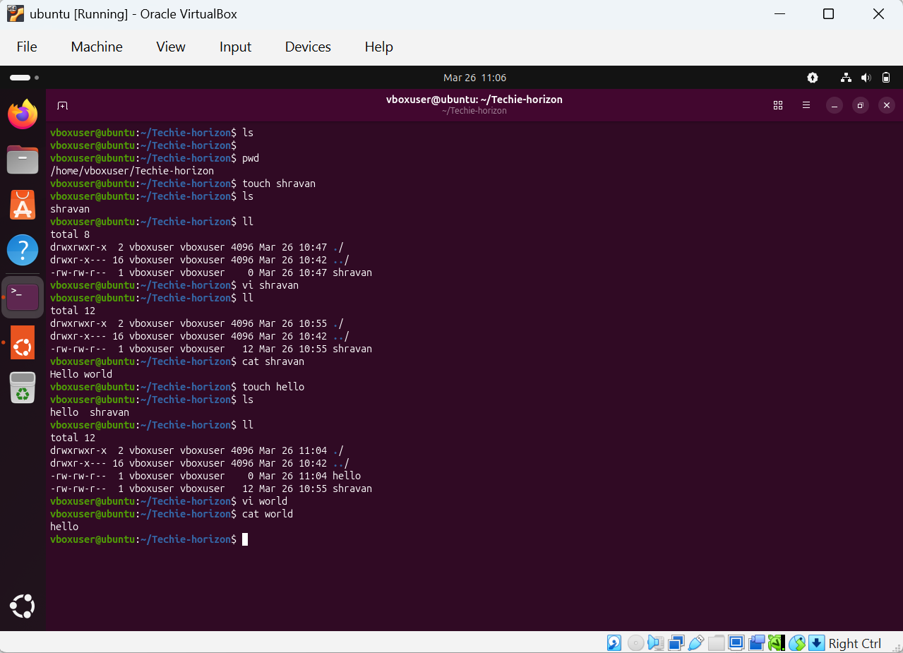
wc word count of file(display number of lines in file)
for example wc shravan
1 2 12 shravan it means 1 line, 2 characters, 12 size of the file

